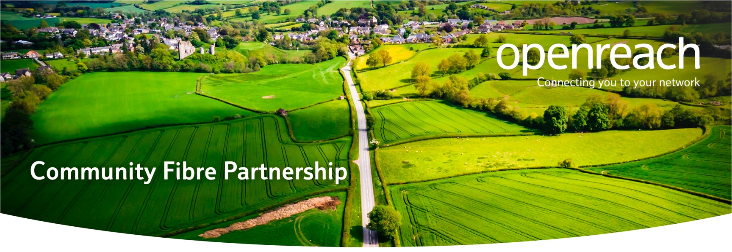

Government vouchers could fully cover your community’s cost of getting FTTP
There is an opportunity to bring full fibre broadband to eligible properties in Feeny, utilising government funding, in partnership with Openreach.

Openreach is one of the government’s registered network build suppliers and have helped hundreds of local communities across the UK to get high-speed broadband. That means they can access online services, video call, work from home, stream HD TV and game online – all at the same time; with no frustrating buffering, no connection dropouts, no waiting your turn. Ultrafast fibre broadband can deliver fantastic benefits for homes and businesses within your community.

Confirm government voucher availability
Government funding is available to help pay for the cost of having the fibre network installed. The Gigabit Voucher Scheme means every eligible rural home can get a voucher worth £1500 (and up to £3500 for small businesses) to improve broadband in their local area.

The voucher scheme could greatly contribute to the cost of the fibre partnership, potentially removing the cost to the community completely. We’ll help throughout the application but the community needs to come together to begin the process and pledge their individual vouchers.

Here is some information to get started.

Step 1
Go to www.openreach.co.uk/connectmycommunityletter to check if you can get funding. You will need to be in an eligible postcode and have broadband speeds of less than 100mbps currently.

Step2
If you’re eligible, pledge your Gigabit Voucher to Openreach*.

Step 3
Encourage your friends and neighbours to do the same.

Step 4

When enough pledges come in Openreach will be in touch about getting the funding in place and the build started. These vouchers can cover the installation cost of bringing better broadband to the community of Feeny – so don’t miss out!

Frequently Asked Questions

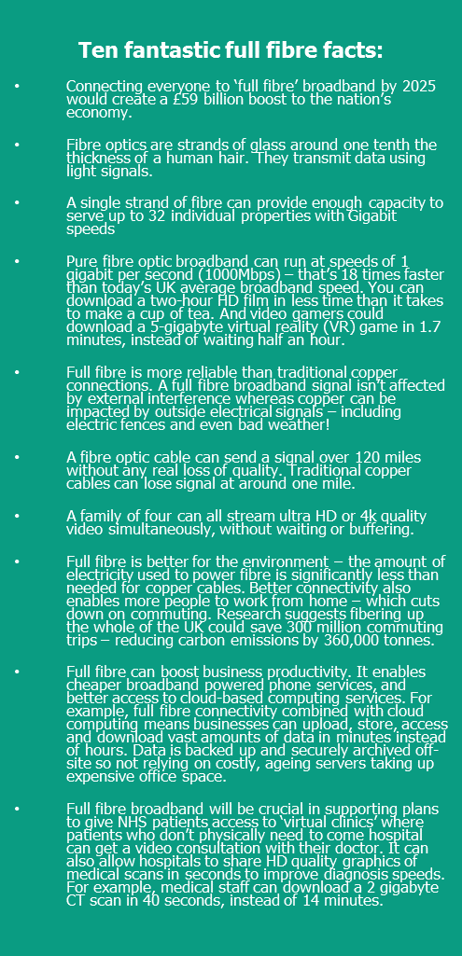
What is the voucher scheme?
The Government recognise that Gigabit-capable, or Ultrafast broadband connections offer the fastest and most reliable speeds available. The Rural Gigabit Voucher scheme has been designed to support rural communities who are eligible for funding, team up with a network provider and bring that technology to their doorstep. We are one of the Government’s registered network build providers.
More information can be found on the Department of Culture, Media and Sport website https://gigabitvoucher.culture.gov.uk/

The terms and conditions attached to the scheme seem very complicated, will I have any contractual obligations at the end of this?
The main ask is that once the network is in place, you sign up with a communications provider of your choice and start enjoying the benefits of ultrafast fibre broadband.

Do I have to order my broadband from BT, or can I choose which provider I use?
No, you are not tied to BT when you pledge your voucher. Openreach will build an open network, meaning that you can order from a service provider of your choice, assuming they sell in your area.

How much will the fibre service cost?
Costs will vary depending on the package and the service provider. There are many price comparison sites available to review, Ofcom in particular is a good source of information.

Can I still keep my telephone number?
Yes. You can keep your existing telephone number as your phone service will continue to be delivered via the traditional copper network. You can however speak to your provider about the alternative options and benefits an ultrafast fibre service can give you.

Can I use the voucher to meet my current broadband costs?
No. The voucher can only be towards the cost of the infrastructure build only. You will have to pay for a broadband package.

My query isn’t answered here, where can I get more information?
Please visit our website www.openreach.co.uk/connectmycommunityletter or email us at communityfibre@openreach.co.uk

