Paula Coyle Counselling MBACP
Child & Adolescent Therapist
Tel: 078 60392524

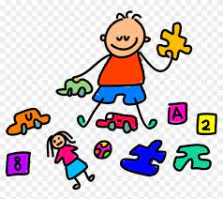
Most children move through developmental milestones easily, however, there are times when things are not so seamless. Stepping into therapy can be an anxious time for parents, however having made the decision, you are not alone as the therapist will work with you towards change in the issues the child is presenting with.

Play Therapy/Child Therapy can help with behavioural and emotional issues, school related problems, anxiety, difficulties with sleep, trauma, bullying, loss, children who can’t play or are withdrawn, children who struggle with anger or aggression, low confidence or self-esteem and children who have difficulty in relationships with others. It helps a child recognise and make sense of their emotions. Every child can benefit from a period of play therapy.
What is Play/Child Therapy:
Play/Child Therapy is a theoretical model where a trained Play/Child Therapist uses play as a therapeutic tool to help children resolve difficulties and achieve their optimal development.
As play is a vital component in every child’s development and when it is used therapeutically it can offer a child a way to express their mixed up feelings in a non verbal, non threatening way. Adults and adolescents use language to express what’s upsetting them, whereas children use play. Play/Child Therapy is not like regular play which is a natural and essential part of a child’s life, as play when used therapeutically helps children make sense of whatever is upsetting them, helps them deal with their emotions more appropriately and helps them learn how to better manage relationships and conflicts, which are building blocks for their future. It can also result in a reduction in anxiety, a raised sense of confidence and self-esteem, a change in behaviour and improved relations with family, teachers and friends.
