

**The Eco Committee**

A key part of the programme is the Eco Committee who are representatives from Primary 4 to Primary 7.

Our committee, through the course of

the year will lead whole

school campaigns, based on areas of the

nine topics, such as

Healthy Living, Energy, School Grounds and Biodiversity, waste, recycling etc.

They will deliver assemblies and competitions, thus driving our school

forward on our Eco journey.



**What is the Eco-Schools Programme?**

Eco-Schools is a global programme engaging millions of children across 64 different countries, making it the largest environmental schools programme in the world.

Eco-Schools is a growing phenomenon, which encourages young people to engage in their environment by allowing them the opportunity to actively protect it. It starts in the classroom, it expands to the school and eventually fosters change in the community at large.

Eco-Schools focuses on nine topics, that encompass every aspect of environmental issues and sustainability awareness. Every topic can be accessed by all ages, through careful planning of ideas and activities.



Eco School

Newsletter

November 2022

Keep up to date on the Eco Committee via the school website and social media.

https://www.stcanicespsfeeny.com/home/

For more information on Eco Schools check out:

[www.ecoschools.org.uk](http://www.ecoschools.org.uk)

[www.jointhepod.org/students](http://www.jointhepod.org/students)

**Our Aim**

Our aim this year is to be once again awarded with Eco Schools Green Flag Award. We were last awarded this in 2017.



We will be focusing on the following four areas: Healthy Living, Energy, School Grounds and Biodiversity. As part of this we will be taking part in the following campaigns:

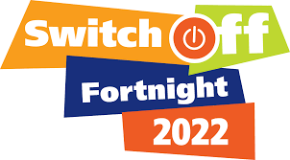 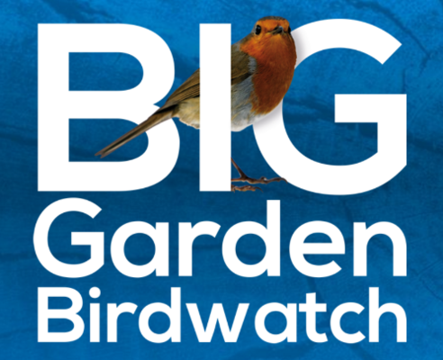

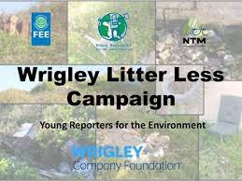 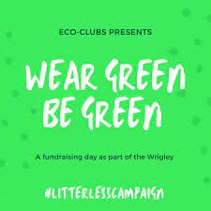



**The Eco Code**

The first role of the Eco Committee was to create an Eco Code (mission statement) which includes our school's core values and commitment towards improving its environmental performance and striving towards a sustainable future. Read ours below:

**Our Eco School Code**

E veryone helping the environment,

C ompost fruit and vegetables,

O nly use what you need.

C arry out litter picks,

O ften eat healthily

D on’t waste paper. Reduce, Reuse, Recycle.

E veryday turn off lights and plugs.