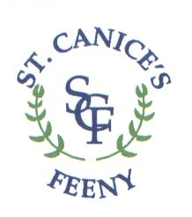
St. Canice’s Primary School

Dear Parents / Guardians,
Tickets will be £4 each and you will be notified when they go on sale.
Dates are as follows:
All shows P1-7
Wednesday 13 December @ 1.15pm – P1/3 & P2
@ 2pm – P4/5 & P6/7
*£4 will cover the above 2 shows*

P1&3 The Christmas Story / P4&5 Santa on Strike
Wednesday 13 December @ 7pm

P2 A Christmas Toy Story / P6/7 Goldilocks in Trouble
Thursday 14 December @ 7pm

We hope to raffle a hamper at each show with tickets @ £1 per strip. Half of the Raffle money will be donated to S.V.D.P.

If you or your business are able to donate a hamper, please contact the school and let us know. We would be delighted if we could get 4 hampers to hold the 4 raffles.

Thank you! 